I hate sport
On Wednesdays Jack's mum does yoga after work, and his dad plays basketball. Jack has to do his homework.
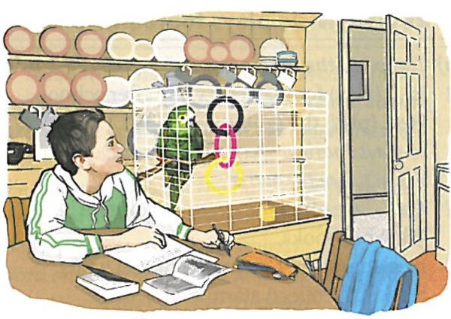
'At least I don't have to do yoga or play basketball,' Jack says. 'I hate sport!' 'Hate sport, hate sport,' Polly says.
'And now we have to do our English project. It's about free time. And what do most people do in their free time? Sport!' 'Hate sport, hate sport.'
'At least you understand me, Polly. Oh no, it's 5.30: I have to go shopping. Then I have to lay the table for dinner. I have to do everything in this house! Because Mum and Dad do sport.' 'Hate sport, hate sport.'
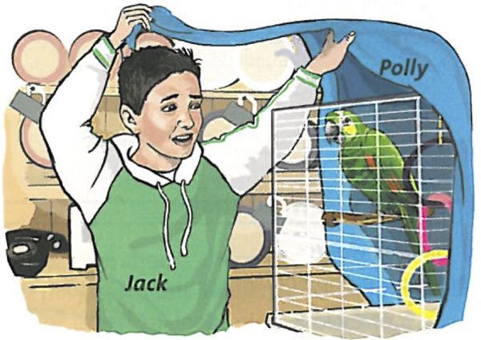
'Does Mum have to do yoga? And does Dad have to play basketball?' 'Basketball, basketball!' Polly says. 'Go team! Go team!' 'Oh no, Polly. Not you too!'

Vocabulary

Ich hasse Sport

